INSTRUCTIONS FOR
SUMMONS, AFFIDAVIT, AND RETURN IN A CASE
FOR FORCIBLE ENTRY AND DETAINER (EVICTION)
IN WYOMING

Read these instructions carefully.

The Summons, Affidavit, and Return are used when you file an eviction case in the Court. These forms will be used with the Complaint for Forcible Entry and Detainer.

You must prepare and serve a Notice to Quit Premises (sometimes called a “three-day notice to quit”) before you file a Complaint. If you did not do this yet, you can find the forms and instructions on the Wyoming Judicial Branch website.

Before You Get Started

In Wyoming, the legal process of evicting someone from a property is called Forcible Entry and Detainer or FED. You can start a Court case for eviction by filing a Complaint for Forcible Entry and Detainer. Return to these instructions after you fill out the Complaint.

When you are ready to file the Complaint, you will also need a Summons and either an Affidavit of Service or a Return of Service. (If you are using forms from the Wyoming Judicial Branch website, the Affidavit of Service and the Return of Service will be together in one file.) You will take the Summons and the Affidavit or Return to the courthouse when you file the Complaint.

The Summons

You will know you are looking at the Summons if the title of the document, between the two long bars on the page, says Forcible Entry and Detainer (Eviction) Summons.

The top of the page has blanks for the name of the county that the Court is in (for example, County of Big Horn) and the number of the judicial district (for example, Fifth Judicial District). When you file the Complaint, the Clerk of Circuit Court can give you this information.

The next blanks are for the name of the Plaintiff and the name of the Defendant. Fill these in exactly the same way you did on the Complaint.

The next blank is for the Case Number. When you file the Complaint, the Clerk of Court will give you the case number. Write the Case Number on the Summons. (The Case Number might contain letters.)

DO NOT write anything else on the Summons. The Clerk, or someone else at the Court, will fill out the rest of the page.
The Affidavit of Service

This form can be used to tell the Court that the Defendant was given a copy of the Complaint and the Summons. Giving the documents to the Defendant is called service. The Defendant must be given a complete copy of the Complaint for Forcible Entry and Detainer and a complete copy of the Summons.

You can ask or hire someone to be the “process server.” The person who serves the documents must be 18 years old or older. If you want to hire somebody to serve the documents, you can ask the Circuit Court Clerk for a list of professional process servers.

Important Note: You might choose to hire someone from your local sheriff’s office to serve the documents. If you choose to do that, you will use the Return of Service instead of the Affidavit. You can read about the Return of Service below.

If you or a process server will be giving the documents to the Defendant, fill in the top of the Affidavit of Service. Use the same information that you wrote on the top of the Summons.
This is the part you fill in:

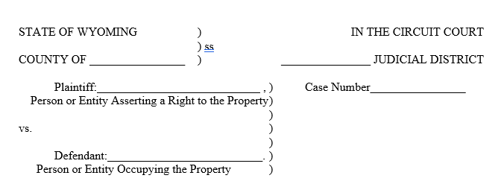

When you file the Complaint, the Clerk will fill in the part of the form that tells the process server where and when to serve the documents. The person who serves the documents must follow the instructions that the Clerk writes on the form. A statute (law) sets a schedule for when the service must happen. If the documents get served too early or too late, the service will not be correct.
This is the part the Clerk fills in:

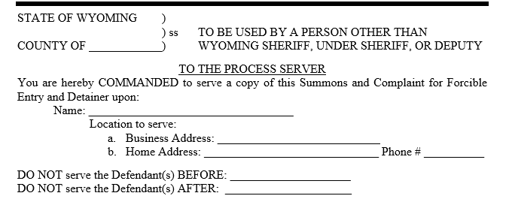

The person who served the documents will fill in the paragraph that starts with “I”. That person (you or the process server) will write their name on the blank line. The date will be written in the next blanks. For example: 7th day of June, 2024. After the words “as follows,” the person who served the documents will write where and how the papers were given to the Defendant. After the word “By,” the person will sign their name. Important Note: Do not sign the Affidavit until you are with a notary. You can learn about what a notary does and how to find one in the Important Things You Need to Know section, below.
If a process server charged you for this service, that person will write the cost on the line labelled “service fees.”
This is the part that the person who served the documents fills in:

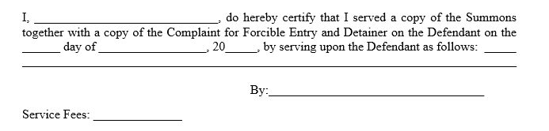

A notary must witness the signature. That means a notary must watch when the Affidavit is signed. The notary will then complete the Affidavit.
This is the part the notary fills in:

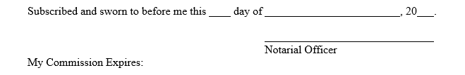

After the documents have been served and the Affidavit is complete, you must take the Affidavit to the Clerk’s office and file it.

The Return of Service

This form can be used to tell the Court that the Defendant was given a copy of the Complaint and the Summons. Giving the documents to the Defendant is called service. The Defendant must be given a complete copy of the Complaint for Forcible Entry and Detainer and a complete copy of the Summons.

The instructions above explain how to use the Affidavit of Service. You will use the Affidavit if someone who is not from the sheriff’s office is going to serve the documents. If you choose to hire someone from your local sheriff’s office to serve the documents, you will use the Return of Service instead of the Affidavit.

If you want to hire someone from your local sheriff’s office to serve the documents, you will need to call their office for information. The sheriff’s office will be able to tell you how much this will cost and how you should deliver the papers to their office.

If someone from the sheriff’s office will be giving the documents to the Defendant, fill in the top of the Return of Service. Use the same information that you wrote on the top of the Summons.
This is the part you fill in:

When you file the Complaint, the Clerk will fill in the part of the form that tells the sheriff where and when to serve the documents. The sheriff must follow the instructions that the Clerk writes on the form. If the documents get served too early or too late, the service will not be correct.
This is the part the Clerk fills in:

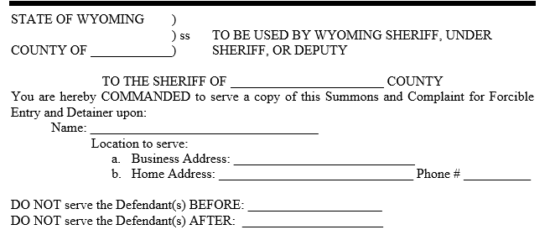

After the Clerk has filled in the forms, you will need to give the sheriff’s office a copy of the Complaint, the Summons, and the Return of Service. You will also need to pay the sheriff’s office their fee. Follow the instructions the sheriff’s office gave you.

Someone from the sheriff’s office will serve the documents and fill in the rest of the Return of Service. After that, the complete Return of Service will need to be filed at the Clerk’s office. Important Note: The sheriff’s office might take the Return to the courthouse OR they might give it back to you to file. It is very important that you understand the sheriff’s instructions so the Return gets filed without a delay.

Summary

- Take the Complaint for Forcible Entry and Detainer
and a Summons
and an Affidavit of Service or Return of Service to the Clerk of Circuit Court.
- Serve a copy of the Complaint and the filled-in Summons to each Defendant.
- File the complete Affidavit of Service or Return of Service at the Clerk’s office.

Important Things You Need to Know

Why do I take some papers to the Clerk twice?
The first time, you need to take the Affidavit or the Return to the Clerk’s office because the Clerk (or someone else at the courthouse) will fill in parts of those documents. After the Summons and Complaint have been served, you need to take the complete Affidavit or Return back to the Clerk’s office so it can be filed.

What will happen after I file the Complaint?
The Court will schedule a hearing (meeting) to give you and the Defendant an opportunity to tell a judge about the situation.

The Summons, which is explained in these instructions, is how the Defendant finds out about the hearing. Before the hearing, the Defendant might file an Answer to your Complaint, but the Defendant is not required to file anything.

What is a Notary and where can I find one?
A Notary Public (usually just called “a notary”) is a person who has a license to witness people signing legal papers and to confirm that the signatures are authentic (which means the signatures are real and were done on purpose). A notary will probably require you to show your driver’s license or some kind of photo ID to prove that you are really you.

Some notaries charge for their services, but it is usually easy to find a notary who will witness your signature and sign your paper for free. If you have an account at a local bank, you can probably get free notary services at that bank. Most libraries also offer free notary services.

